Workshop 3

Creating an entity relationship model

Learning outcomes

Upon successful completion of this workshop, you will have demonstrated the abilities to use crow’s foot notation to construct an Entity Relationship model.

Instructions

. Using the Crow’s Foot notations, create an ERD that for a medical clinic database, using the following business rules:

1. A patient may book appointments with many doctors in the clinic, and a doctor may accept appointments for many patients.
2. An appointment may yield a visit and a visit is associated with one and only appointment. A visit yields a diagnosis and, when appropriate, a treatment.
3. Each patient visit creates a bill.
4. Each bill must be paid. A patient may make many payment transactions to cover the bill total through an installment plan. A payment transaction is associated with one and only one patient.
5. A Payment is processed for one bill at a time by a patient. A bill can be covered though many payment transactions

Student declaration form

Add this declaration on the top of your Workshop4.docx file.

1. We, ------------(mention your names), declare that the attached assignment is our own work in accordance with the Seneca Academic Policy. No part of this assignment has been copied manually or electronically from any other source (including web sites) **or distributed to other students.**
2. Specify what each member has done towards the completion of this work:

|  |  |  |
| --- | --- | --- |
|  | Name | Task(s) |
| 1 |  |  |
| 2 |  |  |
| 3 |  |  |

Requirements

1. Label the primary key for each entity
2. Add and label the foreign keys based on the relationship type between entities.
3. Label the relationship between entities.
4. Ensure the following is recorded in the database:
   1. Patient: patient last name, first name, address, email and phone number.
   2. Doctor: Doctor’s first name, last name, phone number.
   3. Appointment: Appointment date and time,
   4. Visit: data, time, diagnosis, treatment.
   5. Bill: bill’s date, amount.
   6. Payment: for each payment done by the patient towards the bill, the following should be saved: payment date, payment amount, payment type.

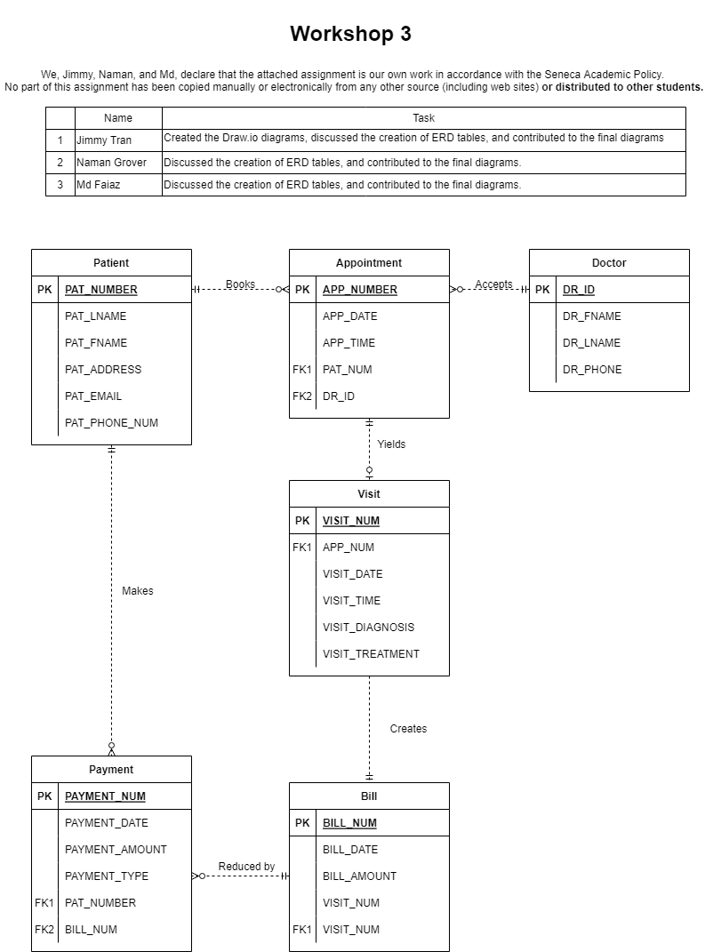

Submission

Save your ER diagram as PNG or PDF, and submit it on BB.